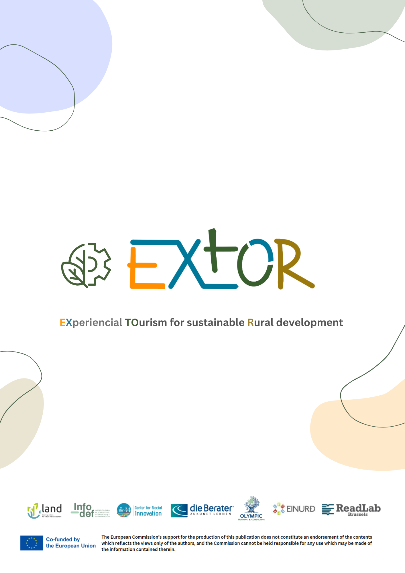

**WP2:** Success stories and needs mapping for VET renewal in rural tourism

**A2.1:** EU collection of success stories and analysis of national trends

EXTOR

Analysis of the current national status of rural tourism and related VET offers

**Desk Research National Report -** **INFODEF**

Country: Spain

Partner: INFODEF

1. ***Does your country have a high level of rural tourism? Is there a variety of rural sectors in your country?***

In January 2022, rural tourism in Spain was growing steadily and gaining popularity among both domestic and international travellers. Spain's diverse landscapes, rich cultural heritage, and traditional rural lifestyle attract tourists seeking authentic experiences away from the hustle and bustle of cities.

Various regions in Spain, such as Andalusia, Catalonia, Galicia, and Asturias, offer unique rural tourism experiences, including stays in charming villages, visits to vineyards and olive groves, outdoor activities like hiking and horseback riding, and opportunities to immerse oneself in local traditions and cuisine.

The level of rural tourism in Spain may vary depending on factors such as seasonality, economic conditions, and government initiatives to promote sustainable tourism development in rural areas. However, it's generally safe to say that rural tourism continues to be an important sector within Spain's broader tourism industry, contributing to the economic growth of rural communities and offering visitors memorable experiences in Spain's picturesque countryside.

Spain boasts a diverse range of rural sectors, each with its own unique characteristics, attractions, and cultural heritage. Some of the prominent rural sectors in Spain include:

**1. Agricultural Tourism:** Spain's fertile lands support a thriving agricultural sector, including vineyards, olive groves, citrus orchards, and various crops. Agricultural tourism allows visitors to learn about traditional farming practices, participate in harvest activities, and enjoy farm-to-table dining experiences.

**2.** **Ecotourism:** Spain is home to diverse ecosystems, including mountains, forests, wetlands, and coastal areas, which provide ample opportunities for ecotourism. Travelers can explore national parks, nature reserves, and biosphere reserves, engage in wildlife watching, and participate in eco-friendly outdoor activities such as hiking, birdwatching, and kayaking.

**3.** **Wine Tourism**: With over 70 recognized wine regions, Spain is one of the world's top wine-producing countries. Wine tourism enables visitors to tour vineyards, visit wineries, and taste a wide variety of Spanish wines, from Rioja and Ribera del Duero to Priorat and Rías Baixas.

**4.** **Cultural Tourism:** Spain's rural areas are rich in history, culture, and architectural heritage. Cultural tourism opportunities include visits to historic villages, medieval castles, Roman ruins, and UNESCO World Heritage sites, as well as attending traditional festivals and experiencing local customs and traditions.

**5. Gastronomic Tourism:** Spanish cuisine is renowned worldwide for its diversity, Flavors, and regional specialties. Gastronomic tourism allows travellers to Savor authentic dishes made from fresh, locally sourced ingredients, participate in cooking classes and food tours, and discover the culinary traditions of different regions.

**6. Adventure Tourism:** Spain's varied terrain offers numerous opportunities for adventure tourism, including mountain biking, rock climbing, caving, canyoning, skiing, and whitewater rafting. Adventure enthusiasts can explore rugged mountain ranges like the Pyrenees and Sierra Nevada or embark on multi-day hiking trails such as the Camino de Santiago.

Overall, Spain's rural sectors offer a wide range of experiences for travellers seeking authentic cultural immersion, outdoor adventures, and relaxation away from urban centres.

1. ***What national and international legislation exists in your country regarding rural tourism?***

In Spain, rural tourism is regulated by a combination of national and regional legislation, as well as international agreements related to tourism and sustainable development. Here are some key aspects of legislation and regulations concerning rural tourism in Spain:

1. National Legislation: At the national level, rural tourism in Spain is primarily regulated under the framework of general tourism laws and regulations, such as:

* The General Tourism Law (Ley General de Turismo), which establishes the legal framework for tourism activities in Spain.
* Various decrees and regulations issued by the Spanish government, including those related to accommodation standards, environmental protection, and tourism promotion.

**2. Regional Legislation:** Spain is comprised of autonomous communities, each with its own legislative powers in areas such as tourism and rural development. Many regional governments have enacted specific laws and regulations to govern rural tourism activities within their territories. These regulations may cover aspects such as land use planning, environmental conservation, tourism promotion, and the licensing of rural accommodation establishments.

**3. European Union Regulations**: Spain, as a member of the European Union (EU), is subject to EU regulations and directives that have implications for rural tourism. These may include legislation related to environmental protection, rural development funding, consumer rights, and the promotion of sustainable tourism practices.

**4. International Agreements:** Spain is a signatory to various international agreements and conventions related to tourism, sustainable development, and cultural heritage conservation. These agreements may influence Spain's approach to rural tourism policy and practice, particularly in areas such as heritage preservation, ecotourism, and the promotion of responsible tourism.

**5. Quality Certification and Standards:** In addition to legal requirements, rural tourism in Spain may be subject to quality certification schemes and standards established by public authorities or private organizations. These certification programs aim to ensure the quality, safety, and sustainability of rural tourism services and accommodation facilities.

Overall, the legal framework governing rural tourism in Spain is complex and multifaceted, encompassing national, regional, and international regulations aimed at promoting sustainable development, preserving natural and cultural resources, and ensuring the quality of tourism experiences in rural areas.

1. ***Are there any vocational training programs for rural tourism in your country?***

Spain offers vocational training programs and educational initiatives aimed at preparing individuals for careers in rural tourism. These programs are designed to equip participants with the necessary skills, knowledge, and competencies to work in various roles within the rural tourism sector. Some of the vocational training options available in Spain include:

**1. Professional Training Courses:** Public and private institutions offer professional training courses specifically focused on rural tourism. These courses cover a wide range of topics relevant to the sector, including hospitality management, tour guiding, customer service, marketing, and sustainable tourism practices.

**2. Tourism and Hospitality Schools:** Spain is home to several tourism and hospitality schools that offer diploma, certificate, and degree programs with specializations in rural tourism. These schools provide comprehensive training in areas such as tourism management, gastronomy, cultural heritage interpretation, and rural development.

**3. University Programs:** Some universities in Spain offer undergraduate and postgraduate programs in tourism management, with optional modules or concentrations in rural tourism. These academic programs provide students with a deeper understanding of the theoretical and practical aspects of rural tourism, as well as opportunities for research and internships in the field.

**4. Training Workshops and Seminars:** Public agencies, industry associations, and non-profit organizations often organize training workshops, seminars, and conferences focused on rural tourism development and management. These events provide valuable networking opportunities and practical insights for individuals interested in pursuing careers in the sector.

5.Government-Sponsored Initiatives: In collaboration with regional governments and tourism authorities, various government-sponsored initiatives aim to promote vocational training and professional development in rural tourism. These initiatives may include subsidized training programs, apprenticeship schemes, and support for entrepreneurship and small business development in rural areas.

Overall, vocational training programs for rural tourism in Spain cater to individuals seeking to enter the industry, as well as professionals looking to enhance their skills and advance their careers in this growing sector. These programs play a crucial role in supporting the sustainable development of rural tourism and fostering economic opportunities in rural communities across Spain.

1. ***What is the responsible governing body/institution for supporting rural tourism entrepreneurs/professionals in your country?***

In Spain, the responsible governing bodies and institutions for supporting rural tourism entrepreneurs and professionals vary depending on the region and level of government. Some of the key entities involved in promoting and supporting rural tourism development in Spain include:

**1. Ministry of Tourism:** At the national level, the Ministry of Tourism (Ministerio de Industria, Comercio y Turismo) plays a central role in formulating policies, strategies, and initiatives to support tourism development across Spain. While its focus extends beyond rural tourism, the ministry may offer support programs, funding opportunities, and policy guidance relevant to rural tourism entrepreneurs and professionals.

**2. Regional Tourism Authorities:** Each of Spain's autonomous communities has its own regional government and tourism authority responsible for overseeing tourism development within its territory. These regional authorities often play a significant role in promoting rural tourism, providing support services, offering funding opportunities, and implementing policies tailored to the specific needs and characteristics of rural areas.

**3. Local Government Entities:** Municipalities and local governments in rural areas also play a crucial role in supporting rural tourism entrepreneurship and development. Local authorities may provide assistance with permits and licenses, offer infrastructure support, promote local attractions and events, and collaborate with tourism stakeholders to enhance the overall tourism experience in rural communities.

**4. Tourism Promotion Agencies:** Public and private tourism promotion agencies at the national, regional, and local levels work to market and promote Spain as a tourist destination, including its rural areas. These agencies may offer resources, marketing support, and networking opportunities for rural tourism entrepreneurs and professionals seeking to attract visitors to their destinations.

**5. Industry Associations and Networks:** Various industry associations, professional networks, and non-profit organizations dedicated to rural tourism operate in Spain. These organizations advocate for the interests of rural tourism businesses, provide training and educational resources, facilitate networking opportunities, and promote best practices in sustainable rural tourism development.

**6. European Union Programs and Initiatives:** As a member of the European Union, Spain has access to EU funding programs and initiatives that support rural development, including rural tourism. These programs may provide financial assistance, technical support, and capacity-building opportunities for rural tourism entrepreneurs and professionals.

Overall, a collaborative effort involving multiple stakeholders at the national, regional, and local levels is essential for supporting rural tourism entrepreneurship and promoting sustainable development in rural areas across Spain.

1. ***What efforts have been made by different authorities in your country to promote rural tourism?***

In Spain, efforts to promote rural tourism are undertaken by various authorities at the national, regional, and local levels, as well as by industry associations and non-profit organizations. These efforts encompass a wide range of initiatives aimed at enhancing the visibility, sustainability, and competitiveness of rural tourism destinations and businesses. Some of the key efforts include:

**1. National Tourism Agency (Turespaña):** Turespaña, under the Ministry of Industry, Trade, and Tourism, plays a role in promoting tourism throughout Spain, including rural areas. It may provide funding, resources, and marketing support for rural tourism initiatives on a national scale.

**2. Regional Tourism Authorities:** Each of Spain's autonomous communities has its own tourism authority responsible for promoting tourism within its territory. These regional authorities often implement specific strategies and programs to support rural tourism development, including marketing campaigns, infrastructure improvements, and funding opportunities for rural tourism projects.

**3. Local Governments:** Municipalities and local councils in rural areas play a crucial role in promoting and supporting rural tourism. They may invest in infrastructure development, cultural preservation, and tourism promotion activities to attract visitors to their communities. Local governments also collaborate with businesses and community organizations to organize events, festivals, and other tourism-related activities.

**4. Industry Associations:** Organizations such as the Spanish Rural Tourism Association (Asociación Española de Turismo Rural) and regional tourism associations represent the interests of rural tourism businesses and professionals. They may provide training, networking opportunities, and advocacy on behalf of the rural tourism sector.

**5. Non-profit Organizations:** Various non-profit organizations and foundations in Spain focus on sustainable tourism development, environmental conservation, and community empowerment in rural areas. These organizations may offer technical assistance, capacity-building programs, and financial support to rural tourism entrepreneurs and initiatives.

**6. European Union Funding:** Spain has access to funding programs and grants provided by the European Union (EU) to support rural development and tourism initiatives. These funds may be allocated for projects that enhance rural infrastructure, promote sustainable tourism practices, and support economic diversification in rural communities.

**7. Marketing Campaigns and Promotion:** Public and private stakeholders collaborate on marketing campaigns to promote rural tourism destinations and experiences in Spain. These campaigns may utilize digital platforms, social media, travel publications, and trade fairs to reach domestic and international audiences and highlight the unique attractions of rural areas.

Overall, the promotion of rural tourism in Spain involves collaboration among multiple stakeholders, including government agencies, industry associations, local communities, and non-profit organizations. By working together, these entities strive to leverage the natural, cultural, and historical assets of rural areas to create sustainable tourism opportunities and enrich the visitor experience.

1. ***In your country are there any funding opportunities for entrepreneurs who wish to start a rural tourism business?***

There are several funding opportunities available for entrepreneurs interested in starting a rural tourism business in Spain. These opportunities may come from various sources, including government grants, subsidies, loans, and support programs. Here are some of the key funding avenues:

**1. European Union Funds:** Spain has access to funding programs provided by the European Union (EU) to support rural development, including initiatives related to tourism. These funds may be allocated for infrastructure improvements, capacity-building initiatives, and business development projects in rural areas.

**2. Regional Development Funds:** Spain's autonomous communities administer their own funding programs to support rural entrepreneurship and tourism development. These regional funds may provide grants, subsidies, or low-interest loans to individuals or businesses launching new rural tourism initiatives.

**3. Government Grants and Subsidies:** National and regional governments in Spain may offer grants and subsidies specifically targeted at rural tourism businesses. These financial incentives may support various aspects of business development, such as marketing, infrastructure upgrades, training programs, and environmental sustainability measures.

**4. Public-Private Partnerships:** Some rural tourism projects in Spain receive funding through public-private partnerships, where government entities collaborate with private investors or tourism operators to develop and promote tourism infrastructure and services in rural areas.

**5. Banks and Financial Institutions:** Entrepreneurs starting a rural tourism business may also explore financing options available from banks and financial institutions in Spain. These may include loans, lines of credit, or other financial products tailored to the needs of small businesses and startups.

**6. Tourism Development Agencies:** Organizations dedicated to promoting tourism development in Spain, such as regional tourism boards and industry associations, may offer financial support or guidance to entrepreneurs seeking to establish rural tourism ventures.

**7. Crowdfunding and Venture Capital:** In addition to traditional funding sources, entrepreneurs can explore alternative financing options such as crowdfunding platforms and venture capital firms that specialize in supporting tourism startups and sustainable business ventures.

It's essential for entrepreneurs to research and assess the eligibility criteria, application procedures, and available funding amounts for different programs and funding sources. Additionally, seeking professional advice from business advisors, industry experts, and financial consultants can help entrepreneurs navigate the funding landscape and maximize their chances of securing financial support for their rural tourism business endeavours.

1. ***Do you have any best practices/successful examples regarding rural tourism in your country?***

Spain has numerous successful examples of rural tourism initiatives that serve as best practices. Here are a few:

**1. Camino de Santiago:** The Camino de Santiago, or the Way of St. James, is a network of pilgrim routes leading to the shrine of the apostle St. James the Great in the Cathedral of Santiago de Compostela in Galicia, Spain. This ancient pilgrimage route attracts thousands of travelers each year, offering a unique rural tourism experience that combines spirituality, cultural immersion, and outdoor adventure. The route passes through picturesque landscapes, historic towns, and rural villages, providing pilgrims with opportunities to stay in traditional albergues (hostels), interact with local communities, and experience the rich cultural heritage of northern Spain.

**2. Pueblos Blancos (White Villages):** The Pueblos Blancos are a collection of charming white-washed villages scattered throughout Andalusia, characterized by their narrow cobblestone streets, whitewashed buildings, and stunning hilltop locations. These villages offer visitors a glimpse into traditional Andalusian life, with attractions such as Moorish architecture, local handicrafts, and regional cuisine. Rural tourism in the Pueblos Blancos region encompasses activities such as hiking, horseback riding, and cultural tours, providing travellers with authentic experiences in rural Spain.

**3. La Rioja Wine Region:** La Rioja is Spain's premier wine-producing region, known for its world-class wineries, vineyards, and picturesque countryside. Rural tourism in La Rioja offers visitors the opportunity to explore historic wine towns like Haro and Logroño, tour family-run bodegas (wineries), and sample the region's renowned wines, including Tempranillo and Garnacha. Wine-related activities such as vineyard tours, wine tastings, and gastronomic experiences contribute to the region's vibrant rural tourism sector.

**4. Sierra Nevada National Park:** Sierra Nevada National Park, located in the southern region of Andalusia, encompasses rugged mountain terrain, alpine meadows, and pristine natural landscapes. Rural tourism in Sierra Nevada offers outdoor enthusiasts a wide range of activities, including hiking, mountain biking, skiing, and birdwatching. The region's scenic beauty, biodiversity, and cultural heritage attract visitors seeking eco-friendly tourism experiences and adventure in a rural setting.

These examples illustrate how Spain's diverse rural tourism offerings capitalize on the country's natural and cultural assets, providing visitors with memorable experiences while contributing to the economic development of rural communities.