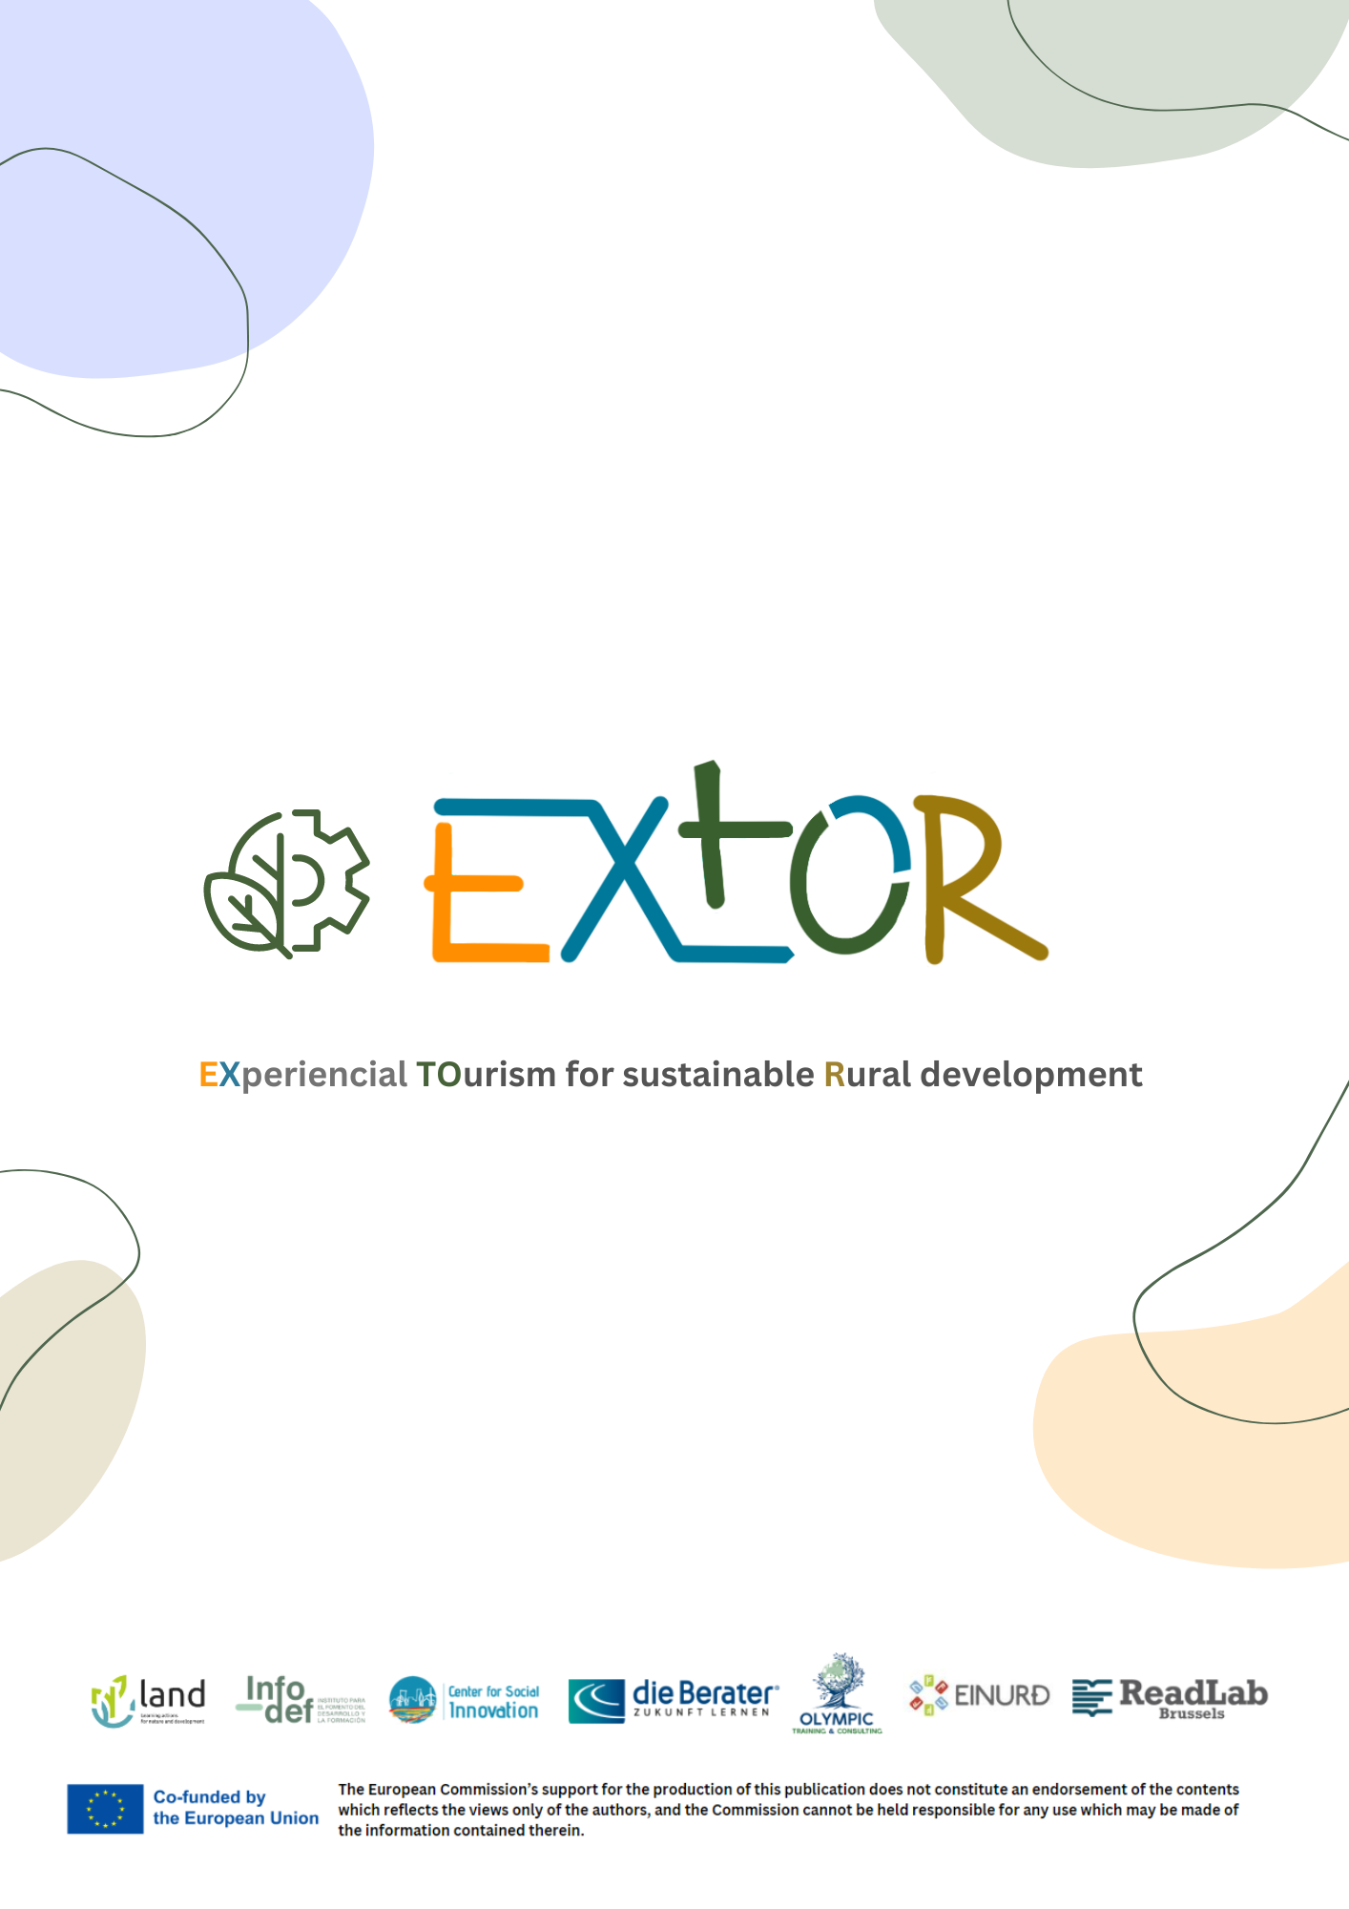

**WP2:** Success stories and needs mapping for VET renewal in rural tourism

**A2.1:** EU collection of success stories and analysis of national trends

EXTOR

Analysis of the current national status of rural tourism and related VET offers

**Desk Research National Report - Einurd**

Country:     Iceland

Partner:      Einurd

1. ***Does your country have a high level of rural tourism? Is there a variety of rural sectors in your country?***

Rural tourism plays a major role in the Icelandic tourism industry.

Number-wise, the SmiEs in the countryside are the biggest group of tourism providers in Iceland.

As is typical for Nordic destinations, the tourism environment in Iceland is mainly characterized by family-run,

small-to-medium-sized tourism businesses. They range from accommodation, to restaurant / café to activity providers. Especially in recent year the number of high-end activities, such as paragliding, zipline, natural wellness spas, has increased.  However, the biggest revenues in tourism are generated by a few market leaders that operate primarily out the capital area of Reykjavík. The (few) large market leaders are positioned in the capital area Reykjavík, from where they offer tours into rural Iceland.

Following the eruption of Eyjafjallajökull in 2010, Iceland received global media attention, resulting in its transformation into a sought-after tourist destination. Over the past decade, tourism has emerged as Iceland’s primary economic pillar, with 2.3 million international visitors in 2018—a nearly seven-to-one ratio of tourists to inhabitants (Ferðamálastofa, 2021).   
In 2019, the year before the COVID-19 pandemic, Keflavík International Airport recorded 1,995,972 international visitors (Ferðamálastofa, 2019a). Despite a significant decline in international arrivals during the pandemic, the tourism industry in Iceland has made a remarkable recovery, welcoming approximately 1.6 million visitors in 2022. Recently, the Icelandic Tourist Board reported an 87.9% year-onyear increase for the first three months of 2023 (Ferðamálastofa, 2022, 2023a).

This rapid growth involves a series of challenges. Most tourists visit the capital of Reykjavík, which serves as the primary gateway into Iceland with 75% of all overnight stays registered there in 2019 (Ferðamálastofa, 2019). The spillover effect of this stream of visitors to the capital mainly affects its close surroundings and the South Coast region, which attracts 81% of tourists

due to its natural attractions, including the famous Geysir hot spring (Ferðamálastofa, 2019). In contrast, only 16% of tourists visit the remote Westfjords, while some 38% travel to the east of Iceland. This concentration of visitors in a small part of Iceland during the summer months has provoked discussions about crowding and over-tourism.

Some 92.4 % (Ferðamálastofa, 2018) of the international tourists who visit Iceland state that its natural attractions are the main reason for their visit.

Since the majority of the market leaders are situated in Reykjavík, trips and tickets to attractions in the countryside are often purchased in the city. This leads to economic leakages from the rural areas, which have few chances to compete with the market leaders.

The imbalance of tourism being centered around the capital while the main attractions are in the countryside reflects the general organizational structure of tourism in Iceland, which is continuously under scrutiny.

The areas in rural tourism in Iceland are categorized as follows:

**South Iceland**

In summer of 2023,  81% of all tourists to Iceland visited South Iceland (Ferdamálastofa, 2023).

Iceland is a country full of geological contrasts and they are best visible in the South, where geothermal heat meets glacial cold. In the Southwest and the Golden Circle Area, the heat is on, providing the energy for Iceland’s many greenhouses and swimming pools. The Southeast shows off Europe’s biggest glacier Vatnajökull, spectacular waterfalls, and black sand beaches on which the powerful waves of the North Atlantic break.

**East Fjords / East Iceland**

In summer of 2023,  41% of all tourists to Iceland visited East Iceland (Ferdamálastofa, 2023).

East Iceland is the home to the country's largest forest, lush farmlands and an assortment of streams and mountains. Thanks to the East's fjords and their natural harbours, a variety of picturesque fishing villages border the coast.

**North Iceland**

In summer of 2023,  48% of all tourists to Iceland visited North Iceland (Ferdamálastofa, 2023).

The North of Iceland truly is a land of contrasts. Its long valleys and peninsulas are interspersed with mountains, lava fields and smooth hills carved out by rivers. The deep and numerous indentations in the coast of the North are at times lush with vegetation, at others barren. As one nears the Arctic Circle in the Northern latitudes, the midnight sun is invariably awe-inspiring.

**West Fjords**

In summer of 2023,  22% of all tourists to Iceland visited South Iceland (Ferdamálastofa, 2023).

One of Iceland's best-kept secrets is undoubtedly the country's northwest corner, named the Westfjords. Isolation and sparse population have preserved the unspoiled nature of the Westfjords and Icelandic folklore culture. Travel guides frequently designate the Westfjords as a destination of excellence. The Westfjords are certainly a must-see for any serious explorer.

**West Iceland**

In summer of 2023,  55% of all tourists to Iceland visited West Iceland (Ferdamálastofa, 2023).

West Iceland is one of Iceland's most geologically diverse regions. Its natural wonders are a nearly exhaustive sampling of all that Iceland offers, ranging from slumbering volcanoes and majestic waterfalls to various flora and wildlife.

**Reykjanes Peninsula**

In summer of 2023,  69 % of all tourists to Iceland visited the Reykjanes Peninsula (Ferdamálastofa, 2023).

The Reykjanes peninsula is often referred to as a geological wonder, where lighthouses outnumber villages. Besides hosting the Keflavík International Airport and, just a few minutes away, the spectacular Blue Lagoon, and the Fagradalsfjall volcano, the Reykjanes peninsula is a destination in its own right.

1. ***What national and international legislation exists in your country regarding rural tourism?***

In Iceland, there are several national and international legislations that regulate rural tourism, such as:

1. **The Nature Conservation Act (No. 60/2013):**aims to protect and preserve Iceland's natural heritage, including rural areas. This act establishes rules and regulations for tourism activities in environmentally sensitive areas.
2. **The Planning and Building Act No. 73/1997, no. 135/1997 and no. 58/1999** which governs the planning and development of rural tourism infrastructure, such as for accommodations, roads, and facilities, equally in urban and rural areas.

Internationally, Iceland is part of the UNESCO World Heritage Convention ( one cultural site, two natural ones), the Ramsar Convention on Wetlands (four sites), all of which aim to protect and preserve natural and cultural heritage sites in rural areas.  Additionally, Iceland is a member of the Nordic Council, which promotes sustainable tourism development in the Nordic countries.

Despite the key role that rural areas play for both locals and tourists, the countryside does not seem to be included in discussions on tourism development as much as the capital area. Innovation and digital applications do not yet play the same role in the rest of Iceland as they do in Reykjavík and other urban areas.

1. ***Are there any vocational training programs for rural tourism in your country?***

In Iceland are a variety of offers for training for tourism providers through different channels.

**Marketing Offices**

As mentioned above, there are seven marketing offices all around Iceland, that are managing the particular areas: Visit South, Visit North, Visit Westfjords, Visit West, Visit Snaefellsnes, Visit East, Visit Reykjavík.

These institutions offer a variety of courses to the tourism businesses. These offers vary between the areas.  As an example, Austurbrú, the regional development association in charge of East Iceland offers courses ranging from setting up webpages and work with Google, founding businesses, hospitality courses, etc.

**Icelandic Tourism Cluster**

The focus of Iceland Tourism Cluster is on Sustainable and Regenerative Tourism, Innovation and digital solutions in the travel industry. The main objective of the Tourism Cluster Initiative is to promote competitiveness and value creation within the Icelandic tourism industry, and to develop a co-operating forum for different stakeholders where the main focus is on linking them together and opening up for interaction between them. The members of Iceland Tourism Cluster Initiative are 50 from all over the value chain of Tourism. The cluster network consists of travel agents, tour operators, hotels, attractions and activities, restaurants, airlines, public relations, IT solutions, maintenance service, engineer service, banks, foreign exchange, law firms, educational institutions and retail.

Through its projects that entail training programs, the Icelandic Tourism Cluster invites small rural tourism entrepreneurs and providers to take part. Most recent projects are:

* Tourbit (development of digital skills)
* CE4RT (sustainable and circular tourism development) and
* NorReg (teaching and development of Nordic regenerative practises in tourism).

**Icelandic Tourist Board**

[The Icelandic Tourist Board](https://www.ferdamalastofa.is/en) is an independent authority under the Ministry of Industries and Innovation. Its activities are regulated through the Tourism Administration Act, with the overall authority in the hands of the Minister of Tourism, Industries and Innovation. The main tasks of the Icelandic Tourist Board are the following:

* registering and issueing operation licences for travel agencies, tour operators, booking services and information centers and monitoring that the requirements for operations are met;
* running Vakinn, the official quality and environmental system for Icelandic tourism;
* regional development, including the development of Destination Management Plans in all regions of the country and coordinating the tourist information system;
* environmental issues such as running the Tourist Site Protection Fund;
* distributing information;
* co-operating with other entities in the field of tourism.

1. ***What is the responsible governing body/institution for supporting rural tourism entrepreneurs/professionals in your country?***

Tourism in Iceland falls under the responsibility of the Ministry of Culture and Business Affairs (Department of Tourism), which controls the development and execution of Icelandic tourism policy and the coordination of collaborative partners, such as the Icelandic Tourist Board (*Ferðamálastofa*) and Business Iceland (*Íslandsstofa*). The former, an independent authority under the umbrella of the minister in charge of monitoring and promoting Icelandic tourism as an economic pillar, focuses on the societal aspects and the care of the natural environment with regard to tourism. Meanwhile, Business Iceland is a public–private organization that oversees exports and investment in tourism as well as marketing communications, campaigns, and the official tourist webpage.

The above mentioned Icelandic Tourism Cluster collaborates with the Ministry in specific projects that aim to foster innovation, digitalization and sustainability in tourism. The projects of the Icelandic Tourism Cluster focus to a big part on rural tourism entrepreneurs and professionals.

Furthermore, the above mentioned DMOs are in charge of supporting their local rural tourism entrepreneurs and professionals through distribution of information and grants. (see above).

1. ***What efforts have been made by different authorities in your country to promote rural tourism?***

Strengthening and fostering rural areas, and rural tourism is stated in the current national Regional Development Plan (Byggdaáaetlún), and also especially in the current Tourism Vision. The current national vision for tourism envisions Iceland to leading in sustainable tourism development by the year of 2030. Within this vision the strengthening of rural tourism entrepreneurs plays a key role.

At the moment Iceland is facing a restructuring regarding a national tourism strategy for tourism development towards more sustainability. In the beginning of the year first steps have been initiated and areas of responsibility been distributed within the particular institutions.

Apart from these big changes in the national strategy, various innovative projects that foster rural tourism have been promoted by both national and local authorities by supporting initiatives with grants.   
Especially the initiatives by the Icelandic Tourism Cluster set a strong focus on rural tourism by  empowering SmiEs and including them into their training and educational programs (e.g. Tourbit for digital skills, CE4RT & NorReg for fostering tourism sustainability).

1. ***In your country are there any funding opportunities for entrepreneurs who wish to start a rural tourism business?***

**The Regional Development Fund (Úppbyggingasjódur):**

Iceland is classified in a variety of Regional Development Associations (most of them also steer the above mentioned marketing offices). The following gives a short overview over these offices:

* Sass – Samtök Sunnlenskra Sveitefélga (South Iceland)
* SSNV – Samtök Sveitafélga á Nordurlandi Vestra (North Iceland)
* SSNE - Samtök Sveitafélga á Nordurlandi Eystra (North Iceland)
* SSS – Samtök Sveitafélaga á Sudurnesjum (Reykjanes Peninsula)
* Austurbrú (East Iceland)
* SSV – Samtök Sveitafélaga Vesturlands (West Iceland)
* Vestfjardastofa (Westfjords)

Each of the above mentioned rural regions offer a Regional Development fund for entrepreneurs, businesses, etc. within the region. The fund's grants fall into three categories:

* Project grants in the field of business development and innovation
* Project grants in the field of culture
* Start-up and operating grants in the field of culture

In line with the regional development plan, there are special emphases, such as the on environmental issues or social diversity. A further focus lies on business development and innovation projects, with emphasis on improved utilization of the region's resource flows.  
There are furthermore a variety of national grants, both by the particular ministries and the Icelandic Centre for Research (Rannís).

**National Grants:**

* **Lóa (Ministry):** Auka við nýsköpun á landsbyggðinni og styðja við eflingu byggða og landshluta með nýskapandi verkefnum.
* **Glókóllur (Ministry):** *Styrkir* til verkefna er varða; fjarskipti, háskóla, hugverkaréttindi á sviði iðnaðar, iðnað, netöryggi, nýsköpun eða rannsóknir og vísindi.
* **Technology Development Fund ( Rannís):** Etc.

1. ***Do you have any best practices/successful examples regarding rural tourism in your country?***

**1-The Westfjords region**

The Westfjords region is a remote and sparsely populated area in Iceland that has seen a growth in tourism in recent years. The region has capitalized on its unique landscapes, including dramatic fjords and rugged coastlines, to attract visitors seeking to explore off-the-beaten-path destinations. The development of eco-friendly accommodations, such as guesthouses and boutique hotels, has helped to support the local economy and preserve the region's natural beauty. Through Social Media campaigns by “Visti Westfjords” the area has gained significant reputation.

**2- “Borgarfjördur Eystri”**

A further success story is the one of “Borgarfjördur Eystri”, a remote fishing village in the East of Iceland. Due to its decline the village has been part of the program “fragile communities”, a national program that aims to help declining communities to thrive. The area is known for its picturesque landscapes, including the iconic Stórurð boulders and Puffin Island, as well as opportunities for hiking, birdwatching, and exploring traditional Icelandic culture. Local businesses have thrived, offering accommodation, guided tours, and cultural experiences that showcase the unique charm of Borgarfjördur Eystri. The community has worked together to promote sustainable tourism practices and preserve the natural beauty of the area for future generations to enjoy.

**3-The Arctic Coast Way:**

In 2019, the Arctic Coast Way has been developed as a scenic driving route along the northern coast of Iceland, showcasing remote and rural communities. This initiative has successfully increased tourism in these regions, offering visitors unique cultural experiences and stunning natural landscapes. <https://www.arcticcoastway.is/>