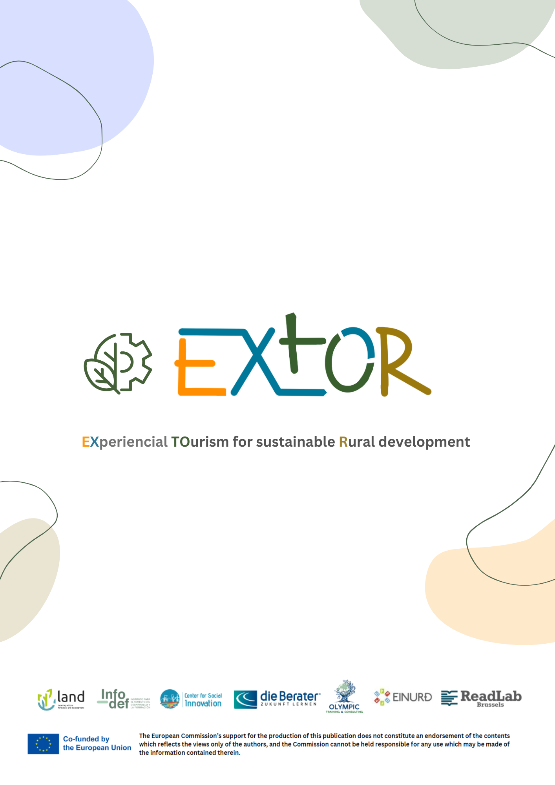

**WP2:** Success stories and needs mapping for VET renewal in rural tourism

**A2.1:** EU collection of success stories and analysis of national trends

EXTOR

Analysis of the current national status of rural tourism and related VET offers

**Desk Research National Report - Olympic Training**

Country: Greece

Partner: Olympic Training

1. ***Does your country have a high level of rural tourism? Is there a variety of rural sectors in your country?***

Under the moto “A lifechanging experience” the Greek National Tourism Organisation (GNTO) in its current campaign (2023) has selected rural tourism as the core product to be promoted. The concept is as follows:

*Holidays in Greece are not easy... Stairs to climb, sand to walk on, roosters to wake you up, hot sun, dirt roads, villages in the middle of nowhere, unusual tastes. But it is these "difficulties" resulting from the untouched nature, the simplicity and authenticity of the country that make a holiday here an unforgettable experience of a lifetime.*

showcasing that except for the traditional triptych of sun, sand and sea that is offered on a well constructed and organized way in the Greek islands, or the urban and conference tourism that have reached a good level of maturity, the country has a lot more to offer through its nature, experiences and other pathways away from the conventional/traditional ones.

 GNTO has identified and quantified the promotion of specific forms of tourism in a desirable proportion of 60% of the proportion of advertising expenditure, with priority being given to the promotion of

* cultural tourism,
* outdoor tourism,
* adventure tourism
* aquaculture activities tourism
* leisure and luxury tourism and
* complementary experiences such as gastronomy and wellness.

There is a reason for placing the focus on rural tourism now as the existing situation in tourism is particularly heterogeneous (Sigala and Christou, 2014).

One can identify two main products that make up the portfolio of the tourism offer in Greece:

a) mass tourism, and

b) various alternative or special forms of tourism.

Between these two main tourism products there are significant differences and differentiations, both in their image and management and in the quality of the services offered and, by extension, in the service provided (Christou and Nella, 2010). However, the one product may not be completely detached from the other as travellers are interested in a multidimensional product / experience even if the main objective of their trip is leisure or 'Sun and Sea' or City Break (INSETE, 2020).

Greece has one of the strongest ‘sun sand and sea’ products in the world (VisitGreece, 2023). Alongside the maritime tourism industry in Greece is performing really well, attracting visitors who enjoy engaging in activities such as cruising, yachting, and coastal tourism. Appealing options are also ‘Cultural andReligious’ tourism that capitalise on Greece's rich historical and cultural heritage(Chavez et al, 2023).

In parallel, many businesses – throughout Greece – offer the opportunity to get to know the Greek countryside through special agrotourism programs. These businesses are classified in the following categories:

* Outlets / exhibitions of agritourism products
* Agritourist catering and recreation centers
* Travel agencies organizing and implementing programs offering outdoor activities and excursions of ecotourism and cultural interests
* Staying overnight at B&B’s on farms
* Business producing traditional products
* Popular art workshops (gogreeceyourway.gr, 2020)

Rural tourism which is at the spotlight of the current research has reasonably good quality services provided - in some cases very good (Sigala and Christou, 2014). However, *the main problem of this tourism sector is the great unevenness of the quality and service provided from one region to another and between different tourism enterprises, which in turn contributes to the formation of an image of reduced product reliability and growing mistrust of the tourism market*.

1. ***What national and international legislation exists in your country regarding rural tourism?***
2. *National legislation*
   1. *National legislation defining rural tourism and the characteristics of subcategories of rural tourism*
      1. Law 4582/2018 Article 4 regulates in Greek legislation the institutional framework concerning rural tourism. More specifically, through this law it is defined that:

1. Rural tourism is any special form of tourism that provides holidays of authentic experiences to visitors – tourists -travelers who come into contact with nature and activities in the countryside, as well as with modern business and leisure activities, which are developed with respect to the environment and the particular cultural elements of each place and contribute to the strengthening of entrepreneurship, the creation of jobs and the economic development of local communities.

Based on the individual organized leisure activities that are developed, rural tourism is subdivided into

1. **Agritourism** which is necessarily combined with the production of agricultural products within the meaning of Article 2(g) of Law 3874/2010,
2. **Wine tourism** - these services are offered in combination with activities related to viticulture and wine production,
3. **Ecotourism - green tourism**- is developed in areas of ecological interest of recognised ecological value, such as ***National Parks, Ramsar wetlands, Natura 2000*** sites and other protected areas and entails activities that do not disturb the environmental balance of the area and are of a scientific and educational nature,
4. **Hiking routes - hiking**, is developed on mountaineering - hiking trails, as specified in the *151344/165/2017 decision of the Deputy Minister of Environment and Energy (B΄ 206)*
5. **Geotourism** - a form of sustainable rural tourism based on the geological and geomorphological characterisation of the geological sites of tourist destinations and on the geo-conservation and interpretation of the abiotic environment

and

1. **Fishing tourism**.
2. **Waste directives** Law 4685/2020 on the modernization of the environmental legislation incorporated into Greek legislation, Directives (EU) 2018/844 and 2019/692 which amongst others provides for the National Waste Management Plan (NWMP). (Sotirchou, n.d.) and Law 4736/2020 aligning with the European Green Deal
3. [**Climate law and NECP 2019**](https://commission.europa.eu/energy-climate-change-environment/implementation-eu-countries/energy-and-climate-governance-and-reporting/national-energy-and-climate-plans_en)**;  Law - 4936/2022** The laws set out targets to fight climate change and reduce the country’s reliance on fossil fuels, affecting each industry within the country.
4. [**Environmental legal framework**](https://mrmguide.eagme.gr/legal-framework-menu/environmental-legislation/)
5. [**Santorini Rodes Chania and Athens Destination Managemetn P**](https://www.destinationmanagementplan.gr/en/)**lanning**
6. The Greek [**National Strategy for Adaptation to Climate Change**](https://ypen.gov.gr/wp-content/uploads/legacy/Files/Klimatiki%20Allagi/Prosarmogi/20160406_ESPKA_teliko.pdf) (NAS)
7. Sustainable Greece and [**Greek Sustainability Code**](https://greekcode.sustainable-greece.com/?lang=en)
8. [Strategic Plan for tourism Development](https://insete.gr/greektourism2030/) which is aligned with the UN SDGs and the European Recovery Fund (ERF)
9. [Greece 2.0 – National Recovery and Resilience Plan](https://greece20.gov.gr/en/) (NRRP)
10. [INSETE Tourism Strategy and Action Plan for 2030](https://insete.gr/wp-content/uploads/2023/05/GREEK_TOURISM2030v2.pdf)

1. ***European legislation***
   1. European Green Deal
   2. The Climate Law and ‘Fit for 55’
   3. EU Taxonomy - classification system establishing a list of environmentally sustainable economic activities, providing companies, investors, and policymakers with appropriate definitions for which economic activities can be considered environmentally sustainable
   4. EU Corporate Sustainability Reporting Directive (CSRD)
   5. EU Sustainable Finance Disclosure Regulation (SFDR)
   6. EU Directive 2019/904 on Single Use Plastics and the EU Directive on packaging waste

1. ***Are there any vocational training programs for rural tourism in your country?***

There are no publically funded or freely offered vocational training programs for rural tourism available in Greece . But there are training courses that are offered upon membership to the [epaithros Rural tourism cluster](https://www.epaithros.eu/en/network/members/businesses).

In addition, there are private initiatives such as the implementation of 30hours self-funded seminars by the [American Farm School of Thessaloniki](https://www.afs.edu.gr/seminard.php?id=27&lg=1) which are addressed exclusively to interested parties/beneficiaries who want to improve their knowledge on issues related to agro-tourism and rural tourism. The participation cost is 250€ and the successful completion of the training may lead to theoretical examination and certification as Agrotourism Facility Manager.

Complementarily, the Ministry of Tourism organizes the implementation of training programmes aimed at employees and temporarily unemployed people who are employed in the tourism sector, aiming at the development of qualified human resources, the enrichment of their knowledge and skills, the enhancement of the adaptability of businesses and professionals to the modern requirements of the tourism market, the improvement of the level of services provided and the competitiveness of the Greek tourism sector. Those seminars are also accessible by people that work regularely or on a temporary basis in rural tourism facilities. The implementation of rapid seminars is also planned to enrich the specific skills of the human resources involved in the tourism sector. Those seminars/training programmes focus on 6 directions/specialisations

* culinary art
* pastry art
* reception services
* catering
* hospitality
* thalassotherapy

INSETE offers  on a regular basis training courses in specific areas of interest such as

* Hospitality operations Management
* HR management
* Hospitality Sales and Marketing
* Food and Beverage
* Culinary arts
* Personal Development
* Leadership and Management

as well as through multiple initiatives, develops complementary training activities such as

* the INSETE Webinar Series which have been developed in two categories
* The training Series
* The expert Series
* The School on Tourism On-Tour
* The freely available training content INSETE Toolkit & INSETE Intelligence

1. ***What is the responsible governing body/institution for supporting rural tourism entrepreneurs/professionals in your country?***

Rural tourism entrepreneurs and professionals are supported and governed by the following bodies

1. ***The* Ministry of Rural Development and Food**: is responsible for the implementation of European initiatives for the development of rural tourism, as the main funding body through the EU Regulations and the management of LEADER funds.

* It provides information and financial support to individual initiatives for the establishment and operation of agri-tourism units. It supports the agri-tourism activities of collective bodies and local authorities.
* It provides training/advice on how to take the initiative.

Its contribution is focused on providing information, awareness and management of Community funds rather than on planning agri-tourism on a national scale.

1. **The GNTO (Greek National Tourism Organisation)**: sets the directions of the country's tourism policy.

* Sets the specifications and grants operating licences for accommodation.
* Its main role is to supervise the proper operation of agro-tourism programmes within the framework of tourism legislation and policy.

It has the legal power to establish zones of controlled tourism development or to prohibit further tourism development in zones identified as tourist saturated.

1. **The Ministry of Environment**: through the management of the Operational Programme ENVIRONMENT, especially in the context of the implementation of the Natura 2000 network:

* supervised and monitors the areas enlisted under the catalogue of NATURA 2000 sites, including 239 habitats (Common Directive 43/92) and 151 wild bird sites (Common Directive 309/79)
* Is responsible for the promotion of the operation of an institutional framework for the organisation, administration and management of protected areas, which will also concern the tourist promotion of these areas.

1. ***What efforts have been made by different authorities in your country to promote rural tourism?***

Tourism and the countryside are key sectors of economic activity with a significant contribution to Greece's GDP.

In recognition of their contribution and importance, and in order to improve the dynamics of Rural Tourism, the competent Ministries – the Ministry of Tourism and the Ministry of Rural Development and Food are working together to highlight special destinations of the country that combine natural beauty and activity in the primary sector, thus promoting alternative forms of tourism such as agrotourism, wine tourism, etc.

The competent body for promoting rural tourism is the Greek National Tourism Organisation (GNTO), which provides information on the benefits of agrotourism through its website and the the special landing pages managed by GNTO such as visitgreece.gr.

Also under the Recovery and Resilience Fund, the project entitled "Subproject 4. Agrotourism and Gastronomy" is funded with the objective to develop a Network that will act as the country's thematic DMO for gastronomy and agri-tourism. The output of AGTIS will be the mapping of existing tourism products and services (e.g. agrotourism units, wineries, olive oil mills, catering businesses), gastronomic experiences (e.g. (e.g. organisation of thematic itineraries, local interactive workshops, visits to local producers of agricultural products and wine, etc.) and the visualisation of the above digitally for the promotion of the participants in the network with the ultimate aim of increasing the brand awareness of the country as a gastronomic destination. The project is linked to another project funded by the Recovery and Reconstruction Fund (Ministry of Rural Development and Food - "Reverse Agriculture"). The digital representation of the AGTIS Network is linked to the portal of the GNTO and  www.visitgreece.gr. The start date of the project was 01/03/2022 and is expected to be delivered by 31/12/2025.

1. ***In your country are there any funding opportunities for entrepreneurs who wish to start a rural tourism business?***

Through the Recovery Fund - Action 1 "Economic Transformation of the Rural Sector" and Subproject 3 "[Green Rural Tourism](https://www.minagric.gr/images/stories/docs/agrotis/Tameio_Anakampsis/sub3_prasinosagrotour_kodikopkeimodhgou_150622.pdf)", financial support is foreseen for "Tourism activities linking the primary sector with tourism”. This intervention concerns investment projects in the tourism sector which link the primary and secondary sector with the tertiary sector, creating a new tourism product (Article 2(15) of the GAC).

On the other hand, the LEADER approach to local development, at the initiative of local communities, promotes the design and implementation of Local Integrated Development Strategies and the development of Destination Management Plans, with the participation of companies at local level in order to effectively address the economic, social, environmental and demographic challenges facing rural areas.

Από την άλλη πλευρά μέσω της προσέγγισης LEADER για την τοπική ανάπτυξη, με πρωτοβουλία των τοπικών κοινοτήτων, προωθείται ο σχεδιασμός και η υλοποίηση τοπικών ολοκληρωμένων αναπτυξιακών στρατηγικών με τη συμμετοχή εταιρειών σε τοπικό επίπεδο προκειµένου να αντιµετωπισθούν αποτελεσµατικά οι οικονοµικές, κοινωνικές, περιβαλλοντικές και δηµογραφικές προκλήσεις που αντιµετωπίζουν οι αγροτικές περιοχές.

In particular, the Strategic Plan of the CAP 2023 - 2027 provides for the allocation of resources for investments in the tourism sector in order to serve specific objectives of the local strategy, the development and improvement of the sustainability of forests with funding through the TAPTOK Leader/CLLD programme and measures[19.2.2.3/19.2.3.3 and 19.2.9](https://www.agrotikianaptixi.gr/metra-paa-pages/leader-clld/ypometro-19-2-stirixi-ylopoiisis-draseon-ton-stratigikon-topikis-anaptyxis-me-protovoulia-topikon-koinotiton-clld-leader/ypometro-19-2-erga-idiotikou-charaktira/).

1. ***Do you have any best practices/successful examples regarding rural tourism in your country?***

|  |  |  |  |  |  |  |  |  |
| --- | --- | --- | --- | --- | --- | --- | --- | --- |
| Successful Examples | Agrotourism | Sustainable tourism | Experiential tourism | Wine tourism | Ecotourism | Sport & Adventure tourism | Cultural tourism | Regenerative tourism |
| [Dexamenes](https://dexamenes.com/the-story/)  [Video](https://www.youtube.com/watch?v=hNj6MgkbPqk) presenting the project |  | ✔ | ✔ | ✔ | ✔ |  | ✔ | ✔ |
| [Eumelia](https://www.eumelia.com/)  [Video](https://www.youtube.com/watch?v=-pCx1TUbJ-o) presenting the project | ✔ | ✔ | ✔ | ✔ |  |  |  |  |
| [Klio’s honey farm](https://www.klioshoneyfarm.com/el/contact/)  or  [MoKa honey](https://www.moka-honey.gr/) | ✔ | ✔ | ✔ |  |  |  |  |  |
| [Open Farm](https://openfarm.gr/)   (network promoting agrotourism businesses |  |  |  |  |  |  |  |  |

***References***

*Beterlsen, L., (2020). Authentic Farm Stays, Educational Vacations and Agritourism in Greece, Go Greece Your Way,* [*https://gogreeceyourway.gr/activities-in-nature/agritourism-in-greece/*](https://gogreeceyourway.gr/activities-in-nature/agritourism-in-greece/)

*Chavez, M., Hohenlohe, X., Lissner, I., Matičević, L., Schreurs, C., 2023. Expert Report: Sustainable tourism in Greece, Institute of the Greek Tourism Confederation (INSETE), Considerate Group.*

*Christou, E., Nella, A., (2010). A review of wine tourism research from 1995 to 2010: Analysis of 110 contributions. Journal of Hospitality and Tourism, 8(1).*

*DELOITTE BUSINESS SOLUTIONS, (2023), The needs for Reskilling and Upskilling of HR in tourism, Institute of the Greek Tourism Confederation (INSETE)*

European Bank for reconstruction and development (2019) Rhodes & Santorini Pilot Destination Management Plans

*European Commision, ( 2023 ), National energy and climate plans, EU countries; 10-year national energy and climate plans for 2021-2030,* [*https://commission.europa.eu/energy-climate-change-environment/implementation-eu-countries/energy-and-climate-governance-and-reporting/national-energy-and-climate-plans_en*](https://commission.europa.eu/energy-climate-change-environment/implementation-eu-countries/energy-and-climate-governance-and-reporting/national-energy-and-climate-plans_en)

*Institute of the Greek Tourism Confederation (INSETE). 2020. The reputation and visitation of Greece - The preferences of tourists. INSETE.gr* [*https://insete.gr/wp-content/uploads/2021/03/21-03_Reputation.pdf*](https://insete.gr/wp-content/uploads/2021/03/21-03_Reputation.pdf)

*Gtp editing team, (2021), Greek Tourism Strategy to focus on Investments, Sustainability, Greek travel Pages, https://news.gtp.gr/2021/11/30/greek-tourism-strategy-to-focus-on-investments-sustainability/*

*QualityNet foundation (2020), Greek Sustainability Code, https://greekcode.sustainable-greece.com/?lang=en*

*Sigala, M., Christou, E.,  2014 , from mass tourism to experiential tourism,* [https://www.hba.gr › 5Ekdosis › UplPDFs › sylltomos14 › 191-206 Sigala 2014.pdf](https://www.hba.gr/5Ekdosis/UplPDFs/sylltomos14/191-206%20Sigala%202014.pdf)

*Sotirchou, D. (n.d.), Waste management in Greece under the current legislative framework, Karageorgiou & Associates Law Firm, https://kalaw.gr/waste-management-in-greece-under-the-current-legislative-framework/*

*Visit Greece, 2023. Islands, visitgreece.gr*